# **Stech Meeting - MacKenzie’s Notes:**

* ***proactivity should be a focus of our solution
  + We are reactive to client requests rather than be proactive to bring clients solutions
* Hypothesis = we are not solving issues properly or effectively and to solve that we are going to change behavior of property managers by giving them insights and directions on how to solve issues proactively
  + If we can boost productivity and make it more efficient and then property managers could manage more clients therefore reducing costs in the long run (reduce cost = secondary benefit)
* Set baseline and and goal for improvement for tenant retention
  + Do we measure the quality of renewals? Not just based on rent decrease etc
  + How do we measure success on retention rate (5% increase)
* Need to make sure we can articulate the current process in our first presentation
  + Want to lay out the current process very detailed so we can talk about the challenge we want to address
  + Then separate the new process into 2 different things (NBA to provide consistency and ability to improve productivity & then how we implement the next best actions to change behavior and the process
    - Need both parts of that solution
    - How do we train the AI and then how it will change the experience for the managers
    - Then draw the line on how it will improve all of our metrics and key performance indicators
    - We need the whole journey
* Need to determine our KPIs
  + Quantity and quality
* NBA areas to address (THE HOW we are going to do it - how do we get the insights?)
  + Are there industry best practices? Use consulting
  + Supervised learning? → here are the things marc or boxer believes to be true about client retention but we will test these with the data
  + Unsupervised learning? → we generate some insights from the data on actions
  + Real time insights → what are the triggering events?
    - How do we collect information and data in the future?
* We need trend analysis for tickets and issues
* Segment issues by level of difficulty, complexity, priority
  + Want to focus on medium and complex issues → impact retention
  + Want to use analytics and data to be more proactive
  + Ex: client has less people parking → could mean reduction in workforce → could plan ahead of time to reach out and ask if they need a reduction in space
* We want to help bottom level of managers rise in productivity by implementing this NBA system that uses past and current data to suggest more proactive actions
  + What insights have they not considered?
  + What issues are higher priority?
  + What trends are they not seeing that we can bring to their attention?
* How are we going to train, test, and get feedback on the system?
  + Journey = here is our structural model, here's how it will impact employees, her is implementation, here is out MVP, etc
* Iteration:
  + Can separate tasks by human intervention and automatic
    - Can we automate 20% of issues and fix those
  + Drill down human intervention even more into → issues that have solutions we can prescribe vs issues we have to escalate to marc or someone else

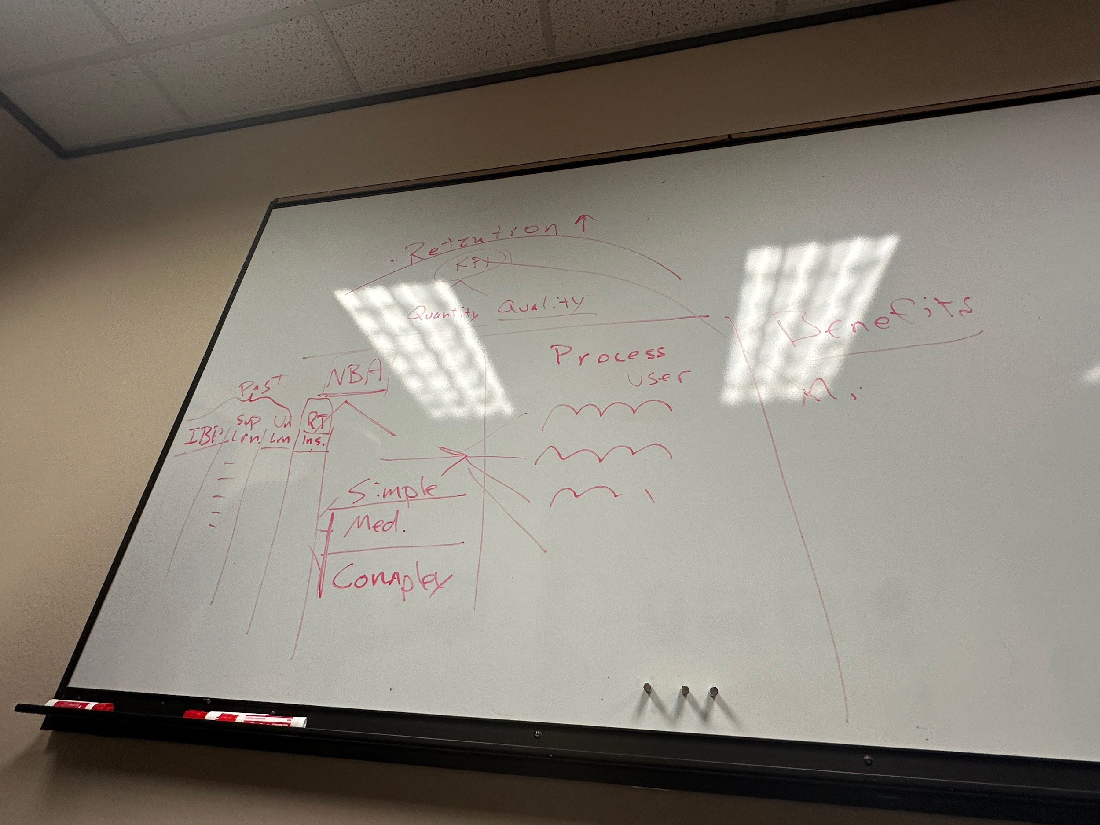

Case study for a better overview on Boxer Properties: <https://www.relayhumancloud.com/wp-content/uploads/sales_documents/boxer-property-management-case-study.pdf>